Risk and Issues Assessment Guide
Risk and issues to consider when planning a service evaluation:
Physical or psychological harm or distress; reputational damage; cost; negative impact on commissioning decisions; causing annoyance; wasted resources (including time); improper disclosure of sensitive or personal information; actual or perceived exploitation or discrimination.
Think of risks as sitting on a continuum, from low to high risk, here are a few examples:
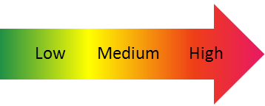
Information
Totally identifiable, sensitive and high numbers
Totally Anonymous
(even to staff), low numbers

Sharing of findings
Just the authors or the team involved
Widely promoted and accessible worldwide, lots of media interest

Questions Asked
Routine, ordinary uncontroversial (e.g. height)
Deeply personal, intrusive or politically sensitive

Consent
Full informed consent, freely given
Covert and hidden

All projects should consider information governance, clinical governance, ethical standards, cost, sensitivity, timing, appropriateness, scope and scale.

